**Docker Final Project**

**Code Files**:

1. app.js

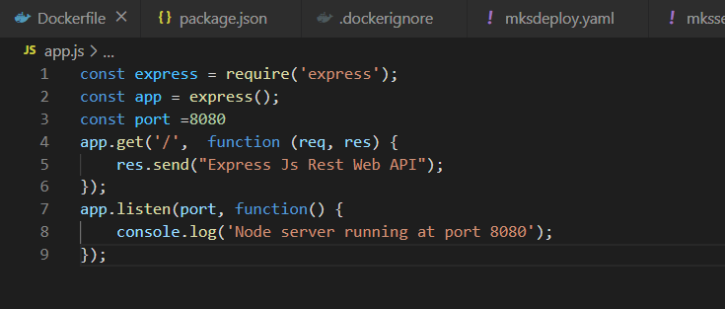

1. package.json

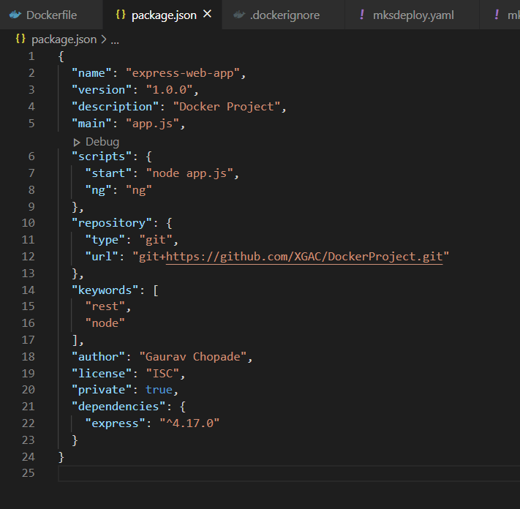

1. .dockerignore

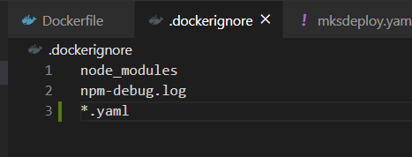

1. Dockerfile

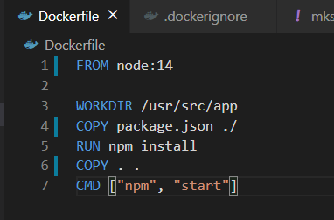

1. mksdeploy.yaml (for Kubernetes cluster)

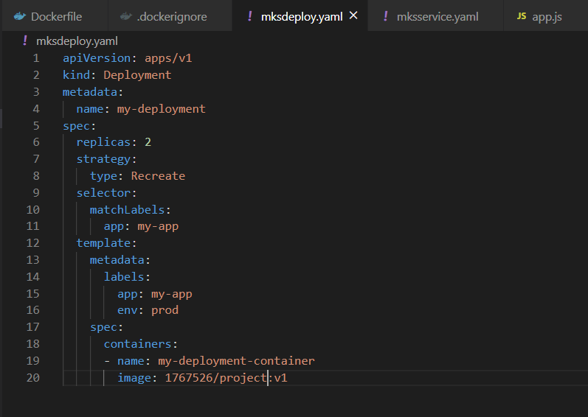

1. mksservice.yaml (for Kubernetes cluster)

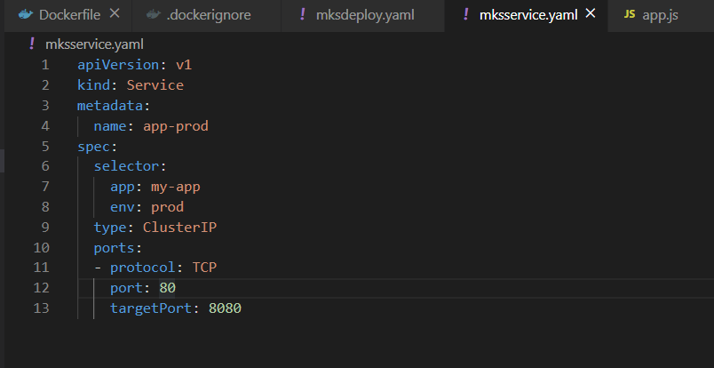

**Commands**:

1. Take Clone from git to VM

$: ***git clone https://github.com/XGAC/DockerProject.git***

1. Build a docker file with current context of docker nodejs webapp application

$: ***docker build -t project .***

1. Tag a image to push it in a docker hub

$: ***docker tag project 1767526/project:v1***

1. Push tagged image in a docker hub repository

*$:* ***docker push 1767526/project:v1***

1. Running a docker container from docker hub repository image

$: ***docker container run -d --name project -p 8080:8080 1767526/project:v1***

1. Initiate a docker swarm and set up a cluster with 2 worker nodes and one manager

$: ***docker swarm init***

$: ***docker swarm join --token SWMTKN-1-5nmfnxohntzdx3rsx091wugoppluy9umpljzuhtnbn24uxrdgz-c20sew1veld9jokichk7k3p3e 172.31.84.178:2377***

1. Creating docker service cluster in all instances having 3 replicas of project image service

$: ***docker service create --name myapp --replicas 3 -p 8080:8080 1767526/project:v1***

1. Create Kubernetes cluster (for this example using Azure Kubernetes cluster)
2. Firstly, deploy deployment yaml file and then service yaml file

$: ***kubectl apply -f mksdeploy.yaml***

$: ***kubectl apply -f mksservice.yaml***

**Note: Currently in this example I have used 1 node Kubernetes cluster as 2 nodes don’t come in free tier and I’m using AZURE Kubernetes cluster. But for 2 node cluster procedure is exact same just need to change count and the output for commands “kubectl get services app-prod” & “kubectl get nodes” will be 2 entries instead of 1 which is currently present.**

**Please It’s a request accept this 2-node cluster setup. Because its exact same as 3 node setups.**

**Screenshots:**

